**Side Self Study:**  
Read about different [Load Balancing concepts](https://www.nginx.com/resources/glossary/load-balancing/) and difference between [L4 Network LB](https://www.nginx.com/resources/glossary/layer-4-load-balancing/) and [L7 Application LB](https://www.nginx.com/resources/glossary/layer-7-load-balancing/).

Let us take a look at the updated solution architecture with an LB added on top of Web Servers (for simplicity let us assume it is a software L7 Application LB, for example – [Apache](https://httpd.apache.org/docs/2.4/mod/mod_proxy_balancer.html), [NGINX](https://docs.nginx.com/nginx/admin-guide/load-balancer/http-load-balancer/) or [HAProxy](http://www.haproxy.org/" \t "_blank))

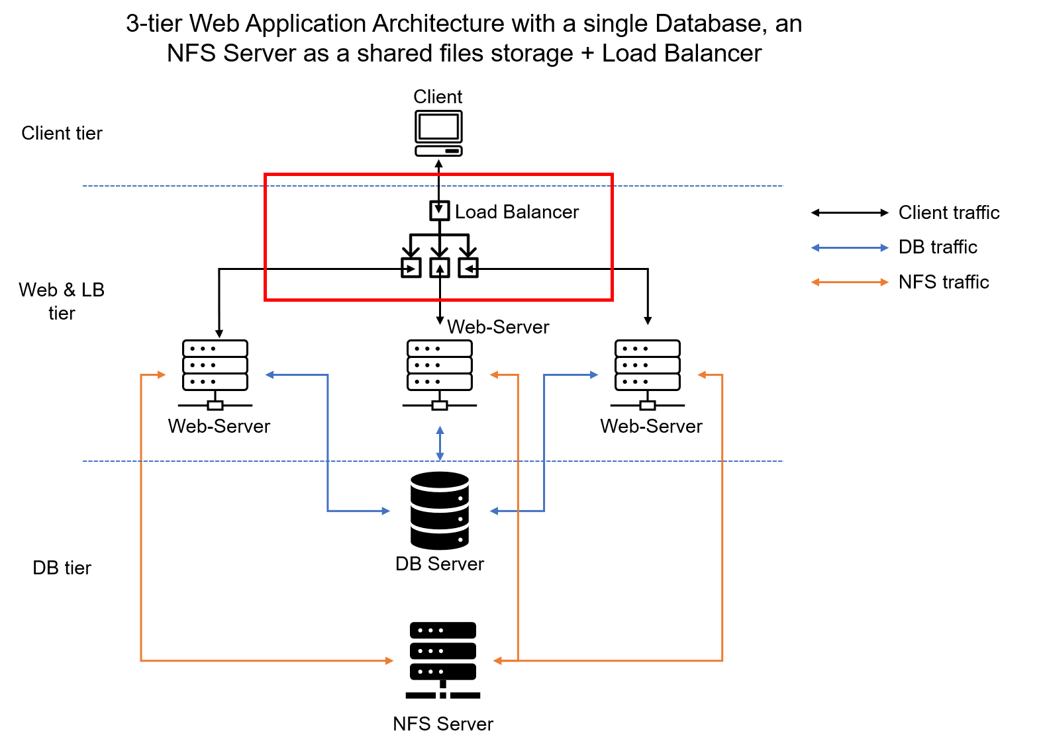

In this project we will enhance our **Tooling Website** solution by adding a Load Balancer to disctribute traffic between Web Servers and allow users to access our website using a single URL.